Use-Case Realization Report
Export Schedule

Issue <1.0>
Revision History
Date | Issue | Description | Author
<29/apr/11> | <1.0> | Initial Document | Koh Ming Jin

Table of Contents
1. Brief Description 4
2. Flow of Events 4
2.1 Standard Flow 4
2.2 Exception 4
3. Interaction Diagrams 4
3.1 Collaboration Diagram for Export Schedule 4
4. Participating Objects 4
4.1 Step 4
4.2 Export Schedule Screen 5
5. Class Diagrams 5
5.1 Domain Class Diagram: Export Schedule 5
6. Derived Requirements 5

Use-Case Realization Report
Export Schedule

Brief Description
This use case enables an operation manager to export a schedule

Flow of Events
The standard flow of events for this use case and any exceptions are described in the following subsections. See section 3.1 for an overview of the participating Actors and Domain Objects.

Standard Flow
The flow of events is described as follows:

- The use case starts when Operation Manager views a list of schedules.
- The Operation Manager selects the Export Schedule option for a particular schedule.
- The Export Schedule Screen is displayed for the Operation Manager to verify the detailed information.
- Once the Operation Manager has verified the information and choose the destination export location, he/she will click the export button.
- The schedule will be exported and saved as an excel file.
- The use case terminates.

Exception
- Destination location not found. If the destination location is not found, a warning message will display to alert the user that the export process has failed.
- Read/Write access rights for the destination location. If the user account does not have the read/write access rights, a warning message will display to alert the user that the export process has failed.

Interaction Diagrams

Collaboration Diagram for Export Schedule
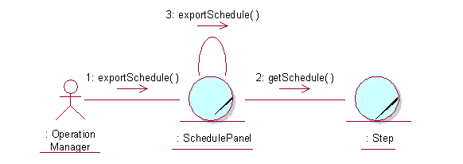

Participating Objects

Step
This object stores the details concerning the schedule information of the COMS.

Export Schedule Screen
This screen is used to display the exportation of schedule details and allows actors to initiate the export process. The Director, Department Manager and Operation Manager actors use this object.

Class Diagrams

Domain Class Diagram: Export Schedule
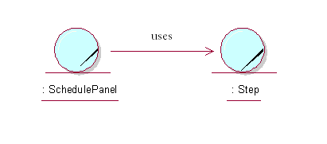

Derived Requirements
The Operation Manager PC keyboard and mouse will be used to enter schedule details (if any) and view all the system responses.

